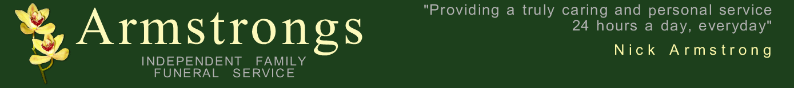
www.funeralhelp.co.uk

Press Notices

These usually follow a standard format from local newspapers, right up to national broadsheets. The easiest way to word them is to look at someone else’s in the press and “copy” the format.

Example
Armstrong,
Florence, (Flo) Nee Hargreaves. Peacefully in St Claire’s Hospice on May 13th aged 69 years. Beloved wife of the late Billy, a much loved mam of Nick and a dear sister to Peggy and the late Eddie. Funeral Service at St Oswald’s Church, Hebburn on Monday May 19th at 12 noon followed by cremation at South Shields Crematorium. Family flowers only please, donations if desired to Cancer Research UK c/o Armstrongs Funeral Service, 43 St Andrews Street North, Bury St. Edmunds. Suffolk. IP33 1TH Tel 01284 723889

Points to note

If someone was always known by a nickname it is acceptable to just use that in the notice.

Using a maiden name for ladies may inform some long lost old school friend….they may have some interesting and funny tales you may never have known about!!

It is not nice to go into too much detail over the cause of death (some papers wont allow it anyway) Peacefully/suddenly/after a long illness bravely borne or even just….”on may 13^{th”}……remember, it will be placed in the deaths column of the paper so there’s no need to go into too much detail.

Age……did the person care about their age…..were they proud of it…or would they want it kept a secret???

Next of kin….spouse first (if already deceased then something like “beloved wife of the late Billy” is fine. Children next, oldest first! You can then mention in-laws if you wish (not totally necessary) and then grandchildren /great grandchildren. It is acceptable if there are lots of grandchildren to just put something like “and also a devoted grandmother/grandma/nana.
IT IS IMPORTANT TO CHECK, DOUBLE CHECK AND THEN GET SOMEONE ELSE TO CHECK SPELLINGS AND TO MAKE SURE NO-ONE HAS BEEN LEFT OUT!!. Far better to keep it nice and simple than to mention everyone…well…almost everyone! It can be un-believably upsetting for a family if mistakes are made with notices.

Service dates and times.
If there is a service in church first the only real point to note is whether you want the committal part private and just for family only (i.e. the interment or the committal at the crematorium) then this must be stated in the notice.

Donations:
Mention the charity by name (so people can make cheques out to the charity concerned and not to the funeral director) It is usually better for us to handle all of the donations on your behalf. A few weeks after the service the we will send you a list of all the people that have made donations and the total amount (not individual amounts) They will then pass these on to the charity concerned and ask them to acknowledge their safe receipt to you.

NEVER PUT A FULL ADDRESS IN THE PRESS. Some people have been the target of crime as you are basically telling people when the house will be empty…unfortunately it has happened. Most papers now wont allow it anyway.
Personal thanks to Nursing Homes, Doctors, family friends, funeral director etc are better placed in an acknowledgement notice following the service. Please see our acknowledgement template for more information.
We will be pleased to word this for you or suggest wording but it can be nice for the family to sit together and word this themselves. We will then check it for you before placing it in the press on your behalf.

We hope that this has been useful for you but please, as always do not hesitate to contact us if we can be of any further assistance at all.

